How do I create a new Outlook profile?

Create a new Outlook profile in Outlook with your Office 365 account.
- Find the Control Panel from your Start Menu
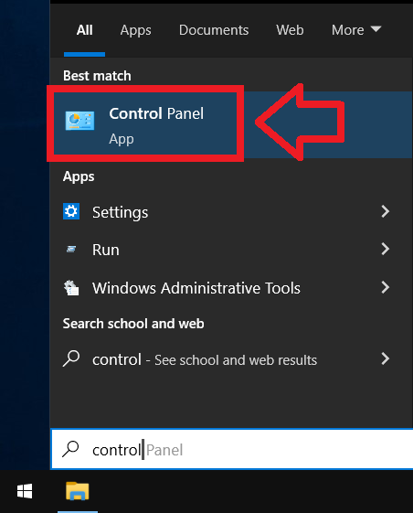
- Open the Control Panel
- If not all items are showing, please sort the Control Panel by viewing Small or Large icons
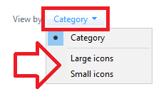
- Open Mail (Microsoft Outlook)
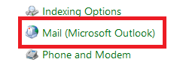
- Click on Show Profiles...
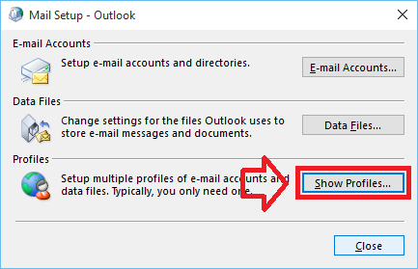
- Add a new profile using the Add button
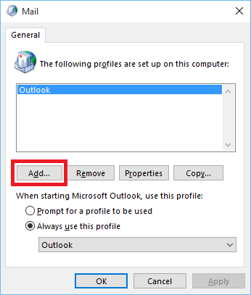
- Give the new profile a name and click OK. You can name it anything you want
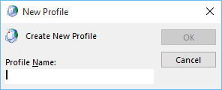
- Confirm your email address
Click Next
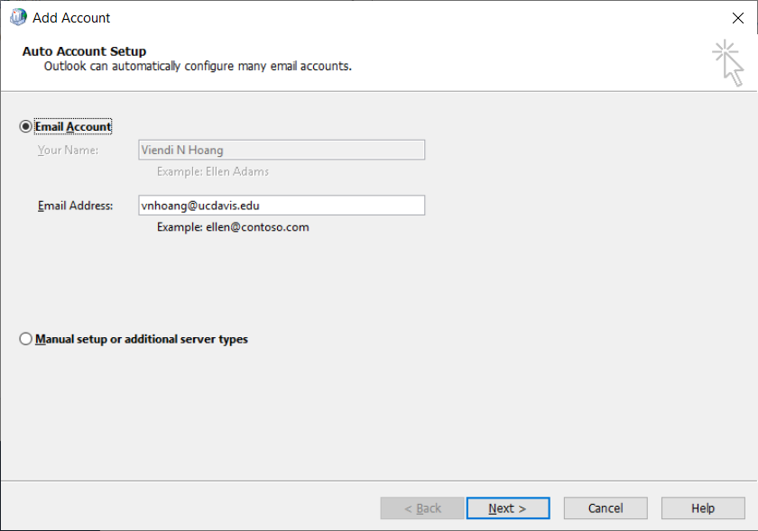
- If necessary, enter in your password
- Click Finish
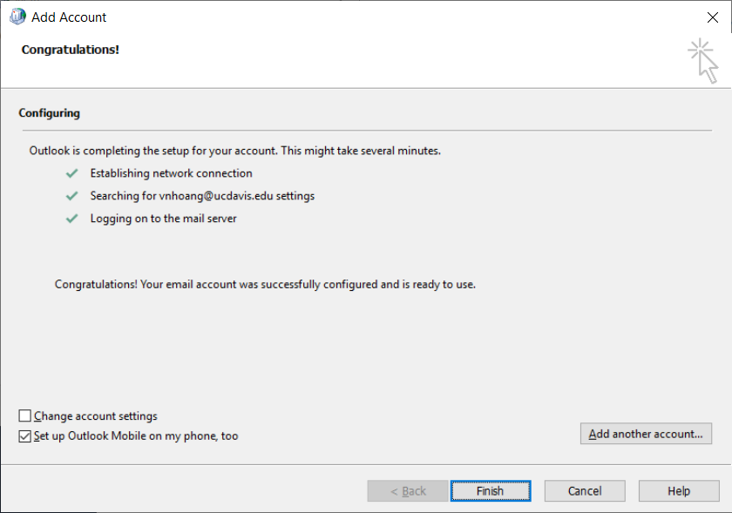
- Optional: Check the box, "Set up Outlook Mobile on my phone, too"
- Optional: Remove the old profile (it just takes up disk space if left there)
- Before closing the Mail settings window, please confirm you are using the new profile
